The Value of Data Center Flexibility: Curtailable Co-Located Data Centers with Behind-the-Meter Generation
Project Proposal, November 10, 2026

1. Motivation and What is Already Known
Research question: What are the incentives for data centers to provide demand response for the grid? And what is the social benefit generated by a data center’s flexible load in the energy market? Would system cost improve?
Global data center electricity consumption is projected to double to about 945 TWh by 2030, growing four times faster than all other demand, and as much as 20% of planned data center capacity could be delayed by grid constraints. To avoid these delays, hyperscalers are building behind-the-meter (BTM) power plants on site: xAI received a permit for 41 natural gas turbines for its Colossus data centers near Memphis, and 130 North American data center projects plan on-site generation. Once the grid connection arrives, these plants risk sitting idle as backup, even though they could help a congested grid: with BTM capacity, the data center can accept curtailment at peak and cover the gap itself (flexible load).

Stakeholder Context and Decision Problem
- Data center developers build BTM plants while waiting in queues, then must retire them, keep them as backup, or use them to accept curtailment.
- ISOs and RTOs (PJM, ERCOT) face congestion in “data center alleys” such as Loudoun County, VA, and queues above 2,000 GW.
- Utilities plan $1.4 trillion of capital spending through 2030, largely for data center load.
- Regulators (FERC Dockets AD24-11-000, EL25-20-000) are setting rules for co-located large loads, and are starting to trade flexibility for faster grid access: FERC’s December 2025 PJM order lets co-located loads take interim non-firm service until upgrades are built, DOE’s October 2025 proposal to FERC would let curtailable large loads seek expedited interconnection studies, and Texas SB 6 (2025) lets ERCOT curtail large loads or switch them to backup generation in emergencies.

Literature Review
- Data center growth and flexibility. U.S. data center demand tripled over the past decade, driven by AI training clusters with 85–95% load factors (Shehabi et al., 2024), and large flexible loads could be integrated with modest curtailment, yet data centers rarely join demand response programs (Norris et al., 2025).
- How flexibility has been modeled. Through workload shifting and deferral (Radovanovic et al., 2023; Chen & Zheng, 2026), siting in nodal capacity expansion (Valencia Zuluaga et al., 2025), storage ancillary services (Liu, Shin & Deka, 2026), or on-site generation against exogenous prices without a network (Liu et al., 2013; Li et al., 2025).
- Network models. Nodal pricing with a linear DC optimal power flow (DC-OPF) is standard (Conejo et al., 2016; Brown et al., 2018).

The Research Gap
To our knowledge, no study evaluates the system-wide impact of letting the ISO curtail a data center at a congested bus while its co-located BTM generation covers the curtailed load, nor how that impact varies with the curtailable share and the BTM-to-load ratio.

2. Problem Statement
In one sentence: we measure how much a curtailable data center with on-site generation lowers total system cost at a congested bus (the ISO’s and society’s view), and whether faster grid access makes that flexibility worthwhile for the data center (its incentive).
We study a hyperscale data center at a congested bus that owns an on-site gas plant and some solar. The data center agrees in advance that the system operator (ISO) may curtail up to a fixed share of its hourly load; when it is curtailed, it runs its own gas plant instead. The ISO decides, hour by hour, how much each utility generator produces, how much data center load to curtail, and how much on-site gas covers it. It must respect every transmission line and generator limit, the agreed curtailment share and the size of the on-site plant, and it must always serve every other customer. Its goal is to meet all demand at the lowest total operating cost. If neither the grid nor the on-site plant can serve the data center in some hour, that compute is lost and counted at a high cost.
In exchange for being curtailable, the data center can connect sooner: a flexible load can be served before the transmission upgrades a firm connection would require. As a single facility is small relative to the market, we treat it as a price-taker, so the least-cost dispatch matches a competitive market with locational marginal prices (LMPs). We compare curtailment levels of 0–100% of the data center load, combined with on-site gas of 25–100% of its peak, against an inflexible baseline, hour by hour over a 7-day July heat week.

3. Optimization Model

Goal and Research Questions
Goal: Quantify the value of data center flexibility as a function of 1) the share of load the ISO may curtail and 2) the BTM capacity relative to the load, whether it produces a net social benefit, and whether faster grid access makes flexibility worthwhile for the data center.
- How does total system operating cost change as the curtailable share increases from 0% to 100%, and at what point does the marginal value of additional flexibility diminish?
- How much BTM capacity is required for curtailment to be valuable?
- From the ISO’s perspective, do flexible data centers lower system cost enough to produce a net social benefit?
- For the data center, is faster grid access worth the cost of being curtailable (the incentive)?

Model Indices and Parameters
Indices: buses $i,j∈N$ (reference bus $ref$); lines $\left(i,j\right)∈L$; utility generators $g∈G$ ($G_{i}$ at bus $i$); data centers $d∈D$ ($D_{i}$ at bus $i$); hours $t∈T$.
Parameters | Description | Unit
$$D_{i,t}$$ | Non-data-center demand at bus $i$ | MW
$L_{d,t}$, ${\hat{L}}_{d}$ | Data center load (IT plus cooling); peak ${\hat{L}}_{d}=\max_{t}L_{d,t}$ | MW
${CF}_{d,t}$, $K_{d}^{sol}$ | Solar capacity factor; BTM solar capacity | –, MW
$c_{g}$, ${\overline{P}}_{g}$, $R_{g}$ | Utility generator marginal cost, capacity, ramp limit | $/MWh, MW, MW/h
$$c^{gas}$$ | Marginal cost of BTM gas generation | $/MWh
$$V$$ | Value of lost compute (penalty for unserved data center load) | $/MWh
$$C^{btm}$$ | Capital and fixed O&M cost of BTM capacity over $T$ | $/MW
$B_{ij}$, $F_{ij}^{max}$ | Branch susceptance; thermal limit | MW/rad, MW
$$σ$$ | Scenario parameter: maximum curtailable share of data center load | –
$$β$$ | Scenario parameter: BTM gas capacity as a share of peak data center load | –

Decision Variables
Decision variables | Description | Unit
$$p_{g,t}≥0$$ | Output of utility generator $g$ | MW
$$g_{d,t}^{gas}≥0$$ | BTM gas output | MW
$$g_{d,t}^{sol}≥0$$ | BTM solar output | MW
$$p_{d,t}^{imp}≥0$$ | Grid withdrawal of data center $d$ | MW
$$c_{d,t}$$ | Curtailed load (defined by (4)) | MW
$$u_{d,t}≥0$$ | Lost (unserved) compute | MW
$$f_{ij,t}$$ | Active power flow on line $\left(i,j\right)$ (free sign) | MW
$$θ_{i,t}$$ | Voltage phase angle at bus $i$ (free sign) | rad
All variables are continuous.

Objective Function
The ISO minimizes total system operating cost: utility generation, BTM fuel and the cost of lost compute.
min Zσ,β=t∈T​g∈G​cg pg,t+d∈D​cgasgd,tgas+d∈D​Vud,t 1
BTM capital cost does not depend on dispatch, so it is evaluated in the net social benefit (15). Payments between the ISO and the data center are transfers and are excluded. Other customers’ load cannot be shed (no VOLL term).

Constraints
Nodal power balance (the dual $λ_{i,t}$ is the LMP): supply equals demand at every bus, and every other customer is served.
g∈Gi​pg,t+j,i∈L​fji,t-i,j∈L​fij,t-d∈Di​pd,timp=Di,t ∀i,t 2
Data center internal power balance: the load is met by gas, solar, grid import or, as a last resort, lost compute.
$$g_{d,t}^{gas}+g_{d,t}^{sol}+p_{d,t}^{imp}+u_{d,t}=L_{d,t} ∀d,t \left(3\right)$$
Curtailment definition: curtailment is the load not served by solar or the grid.
$$c_{d,t}=L_{d,t}-g_{d,t}^{sol}-p_{d,t}^{imp} ∀d,t \left(4\right)$$
Curtailment share limit: the ISO may shift at most a share $σ$ of the load onto BTM gas; lost compute lies outside the cap, so every scenario stays feasible.
$$0≤c_{d,t}-u_{d,t}≤σL_{d,t} ∀d,t \left(5\right)$$
BTM capacity and solar availability:
$$0≤g_{d,t}^{gas}≤β{\hat{L}}_{d} 0≤g_{d,t}^{sol}≤{CF}_{d,t}K_{d}^{sol} ∀d,t \left(6\right)\text{-}\left(7\right)$$
Linearized (DC) power flow and thermal limits: flow follows angle differences and stays within each line’s rating.
$$f_{ij,t}=B_{ij}\left(θ_{i,t}-θ_{j,t}\right) -F_{ij}^{max}≤f_{ij,t}≤F_{ij}^{max} ∀\left(i,j\right),t \left(8\right)\text{-}\left(9\right)$$
Angle bounds and reference bus: angle differences stay in the range where the DC approximation holds.
$$-π/6≤θ_{i,t}-θ_{j,t}≤π/6 ∀\left(i,j\right),t θ_{ref,t}=0 ∀t \left(10\right)$$
Utility generator limits and ramp limits: ramp limits link consecutive hours and days.
$$0≤p_{g,t}≤{\overline{P}}_{g} ∀g,t -R_{g}≤p_{g,t}-p_{g,t-1}≤R_{g} ∀g, t≥2 \left(11\right)\text{-}\left(12\right)$$
Performance metrics: value of flexibility, its marginal step at fixed $β$, and net social benefit.
$$VoF\left(σ,β\right)=Z\left(0,0\right)-Z\left(σ,β\right) Δ{VoF}_{k}=VoF\left(σ_{k},β\right)-VoF\left(σ_{k-1},β\right) NSB=VoF-C^{btm}β{\hat{L}}_{d} \left(13\right)\text{-}\left(15\right)$$
Data center incentive (speed to power): a flexible data center can operate during the $Δτ$ hours it would otherwise wait for transmission upgrades. We compare the value of that earlier compute with the data center’s cost of flexibility over the horizon:
SPV=V Ld Δτ DFC=t∈T​cgasgd,tgas+Vud,t+CbtmβLd 16-17
Flexibility pays for the data center when $SPV$ exceeds $DFC$ over the waiting period. We also report curtailed and lost energy, LMPs at the data center bus and BTM gas use.

Problem Class and Solver
All variables are continuous and every constraint is linear, so the model is a linear program (LP). This is the right class: it solves to global optimality, the duals of (2) give the LMPs directly, and the 168-hour, 118-bus instance (about 60,000 variables per scenario) solves in seconds. We use HiGHS (open source) through JuMP in Julia; Gurobi is a drop-in alternative.

What the Model Leaves Out
- Unit commitment: binaries would make a MILP and blur the LMPs; peak congestion is driven by line limits, which the LP captures.
- AC power flow and losses: the DC approximation is standard for congestion and price studies.
- BTM export and batteries: the plant only covers the data center’s curtailed load, which isolates the value of curtailment.
- Shifting compute in time: curtailed load is covered, not deferred; shifting is studied elsewhere.
- Shedding other customers (no VOLL): settings the grid cannot serve are infeasible, which keeps the result about the data center.
- Uncertainty and strategy: loads and solar are known for the week; the price-taker does not bid strategically.
- Investment and the queue: BTM size is a scenario input; avoided transmission upgrades are not valued, and the interconnection queue is not simulated: the wait $Δτ$ is an input range.

4. Data and Experiments

Data and Assumptions
Input | Value or source | Downloaded?
Network, generators, 24-h bus loads | HW2 IEEE 118-bus files (case_118_network.m, case_118_uc.xlsx): 54 generators, 186 lines | Yes
Multi-day load shape | PJM Dominion metered load, July 2025: dataminer2.pjm.com/feed/hrl_load_metered | Yes
Data center load $L_{d,t}$ | Flat 100 MW (IT plus cooling) at bus 15; 50 MW BTM solar | –
Solar ${CF}_{d,t}$ | Open-Meteo, Ashburn, VA: open-meteo.com/en/docs/historical-weather-api | Yes
BTM gas cost $c^{gas}$ | $40.95/MWh = 9.717 MMBtu/MWh (NREL ATB 2024, F-frame CT) × $3.50/MMBtu assumed gas price + $6.94 VOM | Yes
Interconnection wait $Δτ$ | 1–3 years (input range; varies by utility and region) | –
BTM capital $C^{btm}$ | ATB: $1,319/kW + $25.7/kW-yr O&M at 5.36%, 30 yr ≈ $115,000/MW-yr: atb.nrel.gov/electricity/2024/data | Yes
Lost compute $V$ | $3,000/MWh = GPU rental revenue per MWh: 8 × $3.99 (H100) or $6.69 (B200) per GPU-h ÷ (8.5 or 14.3 kW × PUE 1.2); range $600 (spot) to $6,600 (AWS B200) | Yes
Real LMPs, Ashburn (fallback) | PJM real-time LMPs: dataminer2.pjm.com/feed/rt_hrl_lmps | Yes
Location and synthetic data. Bus 15 has the highest no-data-center price at the system peak ($114/MWh) and the least room for new load (6.8 MW), so the data center sits in a congested pocket. Line limits are 75% of the network file’s ratings (HW2 convention). HW2 gives one 24-hour day of bus loads; we build a 7-day week by scaling it with the daily peaks of real PJM Dominion load, keeping HW2’s spatial pattern and real day-to-day variation. The data center load is flat because AI training clusters run near constant load. No random numbers are used.

Scenario Design
Each scenario combines a curtailment share $σ$ with a BTM-to-load ratio $β$. For the data center’s 100 MW load, $β$ translates directly into BTM capacity; $β=50\%$ is the “50/50” configuration. S0 ($σ=β=0$) is the inflexible baseline.
 | $σ$ = 0% | $σ$ = 25% | $σ$ = 50% | $σ$ = 100%
$β$ = 25% (25 MW) | S1 | S2 | S3 | S4
$β$ = 50% (50 MW) | S5 | S6 | S7 | S8
$β$ = 100% (100 MW) | S9 | S10 | S11 | S12
Sensitivity analyses (two). (1) Value of lost compute $V$, our weakest assumption: $600, $1,000, $3,000 and $6,600/MWh (spot to hyperscaler GPU rental prices). It tests whether the answers to the research questions hold or only their size changes. (2) Congestion: line ratings at 75% (base), 80% and 90%. It tests whether the value of flexibility depends on the data center sitting in a congested pocket. We tested gas cost and BTM capital cost but omit them: neither changes any conclusion (gas cost moves VoF by under 5%; capital cost shifts NSB by a fixed amount and never changes its sign).
Expected and null results. We expect a large value of flexibility at modest $σ$ and $β$, with diminishing returns and a positive net social benefit after BTM capital, and a speed-to-power value far above the data center’s cost of flexibility (100 MW × 168 h × $3,000/MWh ≈ $50M of compute per week of earlier access, against about $0.2M per week of BTM capital). A null result is $VoF≈0$: the bus is not congested, or the local price rarely exceeds the BTM gas cost, so flexibility is worthless there, which would itself tell regulators where curtailment contracts are not worth paying for. Fallback: if the 118-bus week proves unusable, we run the same model on a single peak day, or as a price-taker using the real Ashburn LMPs in place of the network.

5. Results: Toy Example
We solve the smallest instance that uses every part of the model: three buses and two hours (toy_example.jl; results/toy_example.csv). Three lines form a triangle (equal reactance, 100 MW limit each). Bus 1 (reference): 300 MW at $20/MWh. Bus 2: 70 MW peaker at $80/MWh and a town load of 40 MW at night (hour 1) and 120 MW at the evening peak (hour 2). Bus 3: town load 20 / 50 MW and the data center, a flat 100 MW with 50 MW of solar (capacity factor 0, then 0.4). $c^{gas}$ = $40.95/MWh, $V$ = $3,000/MWh, $C^{btm}$ = $13.14/MW-h (ATB). All 13 scenarios solve in under a second.
Toy example, hour 2 (evening peak). Cost, VoF and NSB cover both hours. All σ = 0 scenarios equal S0; S3, S4, S6 and S10 dispatch like S2; S8 and S11 like S7.
Scenario ($σ$, $β$) | BTM gas (MW) | Lost compute (MW) | Peaker (MW) | LMP bus 3 ($/MWh) | Cost $Z$ ($) | VoF ($) | NSB ($)
S0 (0%, 0%) | 0 | 5 | 70 | 3,000 | 27,300 | 0 | 0
S2 (25%, 25%) | 25 | 0 | 30 | 140 | 10,524 | 16,776 | 16,119
S7 (50%, 50%) | 50 | 0 | 10 | 50 | 9,847 | 17,453 | 16,139
S12 (100%, 100%) | 70 | 0 | 0 | 40.95 | 9,666 | 17,634 | 15,006
- Flexibility needs both $σ$ and $β$. The ISO can shift at most $min\left(σL,β\hat{L}\right)$ onto gas, so with $σ=0$ the BTM plant sits idle and the result equals the baseline.
- Diminishing returns. The first 25 MW of flexibility saves $16,776, the next 25 MW only $676 and the last step $181.
- Prices. In S0 line 1–3 is full and the peaker is at its limit, so 5 MW of compute is lost and $V$ sets the bus-3 price at $3,000. Curtailing 25 MW lets the peaker set it at $140 (2 × $80 − $20); with 50 MW it falls to $50, and in S12 to the gas cost. At night every price is $20, below the gas cost, so the ISO never curtails.
- Net social benefit is positive. After BTM capital, every flexible scenario comes out ahead (S2 $16,119, S7 $16,139, S12 $15,006). Most of the saving is avoided lost compute (5 MW × $3,000), which is why $V$ is our main sensitivity. Two peak hours overstate the benefit per hour; the 168-hour study measures it over a week.

7. Division of Labor
Scope | John | Diana
Problem statement | Defined problem and scope | Defined problem and scope
Literature review | Gathered and reviewed sources | Gathered and reviewed sources
Optimization model | Defined initial model | Reviewed proposed model, made update
Toy example | Built and solved the toy example | Reviewed data and results
Model run |  | –
Results
AI use. Claude Opus 5.5 and Gemini 3.1 Pro were used during the literature review to confirm available papers, to validate data assumptions, to check the model’s consistency, and to help write and debug the code; results were verified by the authors.

References
- International Energy Agency, Energy and AI, 2025. https://www.iea.org/reports/energy-and-ai/executive-summary
- Southern Environmental Law Center, press release, March 10, 2026. https://www.selc.org/press-releases/mississippi-regulators-rubber-stamp-air-permit-for-xai-power-plant-ignoring-overwhelming-public-pushback/
- S&P Global Commodity Insights, 2026. https://www.spglobal.com/energy/en/news-research/latest-news/natural-gas/052726-pipeline-operators-strike-deals-as-data-centers-turn-to-colocated-generation
- J. Rand et al., Queued Up: 2026 Edition, Lawrence Berkeley National Laboratory, 2026. https://emp.lbl.gov/queues
- E&E News, “US utilities planning record-breaking capital spending,” April 15, 2026. https://www.eenews.net/articles/us-utilities-planning-record-breaking-capital-spending/
- A. Shehabi et al., 2024 United States Data Center Energy Usage Report, LBNL-2001637, December 2024.
- T. H. Norris, T. Profeta, D. Patino-Echeverri and A. Cowie-Haskell, Rethinking Load Growth, NI R 25-01, Nicholas Institute, Duke University, 2025.
- A. Radovanovic et al., “Carbon-Aware Computing for Datacenters,” IEEE Transactions on Power Systems, 38(2), 2023.
- Y. Chen and X. Zheng, “To Defer or To Shift? The Role of AI Data Center Flexibility on Grid Interconnection,” arXiv:2604.05376, 2026.
- T. Valencia Zuluaga, J.-P. Watson and S. Pang, “Nodal Capacity Expansion Planning with Flexible Large-Scale Load Siting,” arXiv:2510.19781, 2025.
- S. Liu, S. Shin and D. Deka, “Watts vs. Bytes: Turning Data Centers into Grid Assets via Storage Compute Co-Optimization,” arXiv:2605.16190, 2026.
- Z. Liu, A. Wierman, Y. Chen, B. Razon and N. Chen, “Data center demand response: Avoiding the coincident peak via workload shifting and local generation,” Performance Evaluation, 70(10), 2013.
- S. Li, L. Tong and T. D. Mount, “Energy Management for Renewable-Colocated Artificial Intelligence Data Centers,” arXiv:2507.08011, 2025.
- A. J. Conejo, L. Baringo, S. J. Kazempour and A. S. Siddiqui, Investment in Electricity Generation and Transmission, Springer, 2016.
- T. Brown, J. Hörsch and D. Schlachtberger, “PyPSA: Python for Power System Analysis,” Journal of Open Research Software, 6(1), 2018.
- FERC, Commissioner-led Technical Conference Regarding Large Loads Co-Located at Generating Facilities, Docket AD24-11-000, November 1, 2024; Constellation Energy Generation v. PJM, Docket EL25-20-000, 2025.
- FERC, Order directing PJM reforms for co-located large loads, December 18, 2025. https://www.jdsupra.com/legalnews/ferc-directs-pjm-to-facilitate-faster-3604437/
- U.S. Department of Energy, letter directing FERC to act on large load interconnection (ANOPR), October 23, 2025. https://www.klgates.com/DOE-Directs-FERC-to-Take-Action-on-Large-Load-Interconnection-10-30-2025
- Texas Senate Bill 6 (89th Legislature), large load interconnection, June 20, 2025. https://www.bracewell.com/resources/texas-senate-bill-6-ushers-in-major-overhaul-of-large-load-interconnection-and-grid-access-rules/
- NREL, 2024 Annual Technology Baseline. https://atb.nrel.gov/electricity/2024/data
- PJM Interconnection, Data Miner 2 (hrl_load_metered, rt_hrl_lmps). https://dataminer2.pjm.com
- Neurohive, “Cloud GPU Pricing in 2026: What It Costs to Rent an H100, B200 or RTX 5090,” November 2026. https://neurohive.io/en/guides/cloud-gpu-pricing/
- NVIDIA, DGX B200 User Guide (14.3 kW maximum system power). https://docs.nvidia.com/dgx/dgxb200-user-guide/introduction-to-dgxb200.html; NVIDIA DGX H100 (8.5 kW). https://flopper.io/system/nvidia-dgx-h100

Appendix
Appendix 1. Global data center electricity consumption, by equipment, Base Case, 2020–2030 (IEA)
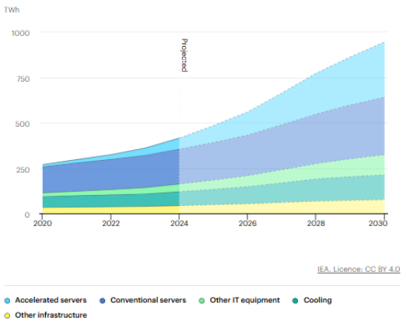
Appendix 2. Global data center capacity additions and capacity at risk of connection delay due to grid constraints, 2025–2030 (IEA)
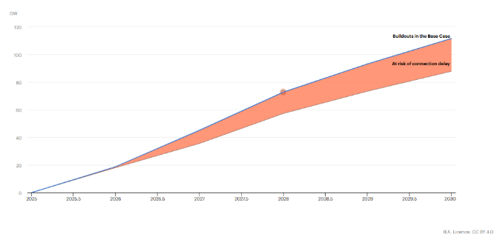
Appendix 3. Gas turbines for the xAI facility
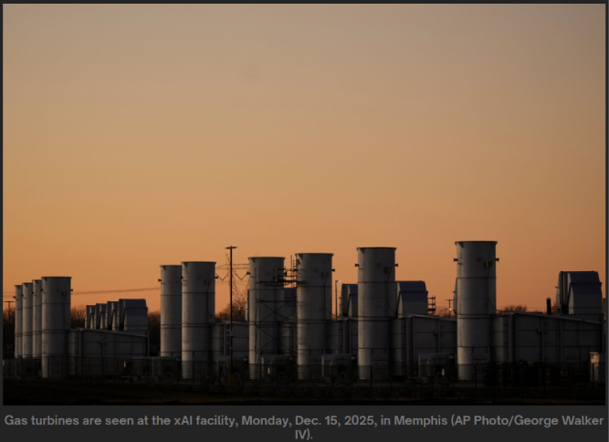
Appendix 4. Data center Colossus in Memphis
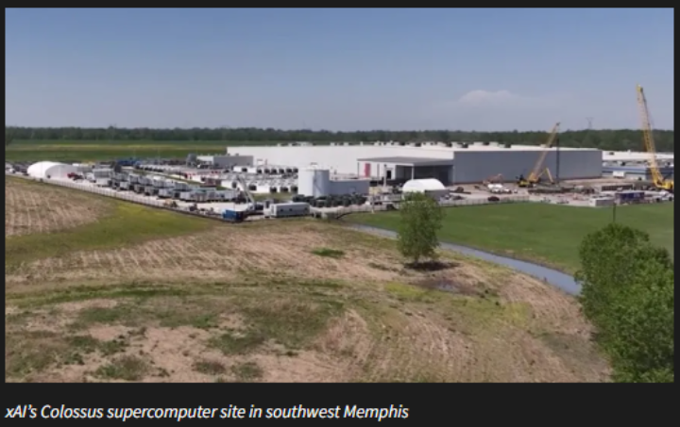
Appendix 5. Grid-interactive architecture (Regime C) vs. the usual setup (Regime A)
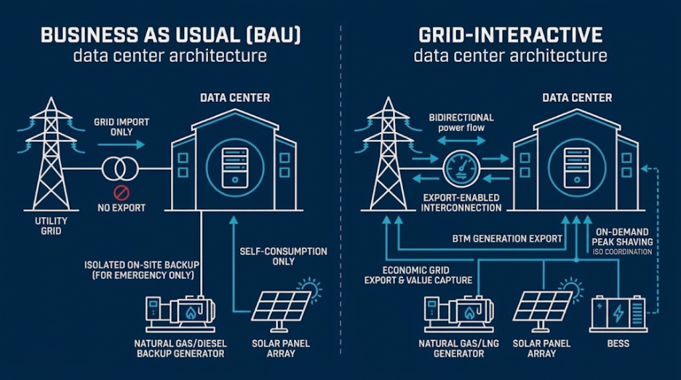

International Energy Agency, Energy and AI, 2025. https://www.iea.org/reports/energy-and-ai/executive-summary
Southern Environmental Law Center, press release, March 10, 2026.
S&P Global Commodity Insights, CERA tracking through Q1 2026.
J. Rand et al., Queued Up: 2026 Edition, Lawrence Berkeley National Laboratory, 2026.
E&E News, “US utilities planning record-breaking capital spending,” April 15, 2026.
FERC order on PJM co-located load, December 18, 2025; summary: https://www.jdsupra.com/legalnews/ferc-directs-pjm-to-facilitate-faster-3604437/
DOE letter directing FERC on large load interconnection, October 23, 2025; summary: https://www.klgates.com/DOE-Directs-FERC-to-Take-Action-on-Large-Load-Interconnection-10-30-2025
Texas Senate Bill 6, signed June 20, 2025; summary: https://www.bracewell.com/resources/texas-senate-bill-6-ushers-in-major-overhaul-of-large-load-interconnection-and-grid-access-rules/

